DormNest  
(Student Accommodation Finder)

Parameshwaran K – 2022503509

Inbavanan K – 2022503507

Pavithran S - 2022503705

**Class Diagram:**

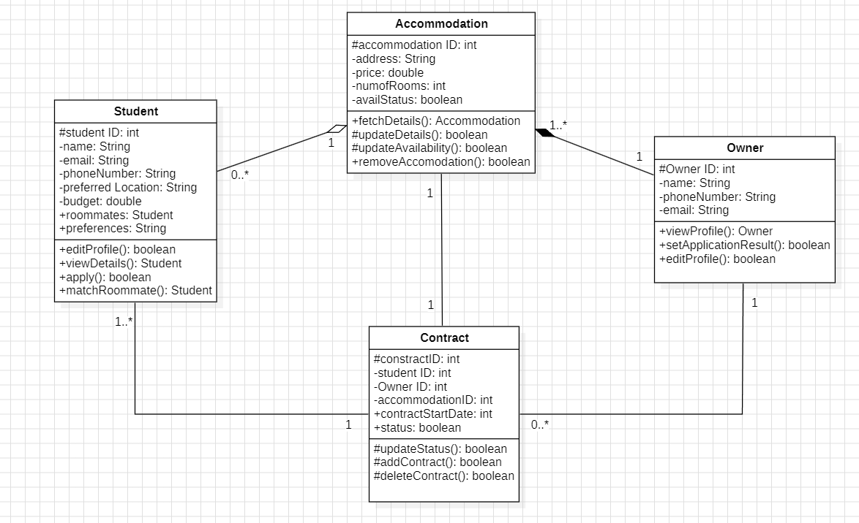

[code in next page]

**Code Implementation for “Accommodation Class”:**

public class Accommodation {

    public Accommodation() {

    }

    protected int accommodationID;

    private String address;

    private double price;

    private int numofRooms;

    private boolean availStatus;

    public Accommodation fetchDetails() {

        return this;

    }

    protected boolean updateDetails(int newID, String newAddress,

            double newPrice, int newNumofRooms) {

        this.accommodationID = newID;

        this.address = newAddress;

        this.price = newPrice;

        this.numofRooms = newNumofRooms;

        return true;

    }

    protected boolean updateAvailability(boolean status) {

        this.availStatus = status;

        return true;

    }

    public boolean removeAccommodation() {

        this.accommodationID = -1;

        this.address = "";

        this.price = 0;

        this.numofRooms = 0;

        this.availStatus = false;

        return true;

    }

    public void displayDetails() {

        System.out.println("Accommodation ID: " + accommodationID);

        System.out.println("Address: " + address);

        System.out.println("Price: " + price);

        System.out.println("Number of Rooms: " + numofRooms);

        System.out.println("Availability Status: " + (availStatus ? "Vacant" : "Not Vacant"));

        System.out.println();

    }

}

**Main Class:**

import java.util.*;

public class Main {

    public static void main(String[] args) {

        Scanner sc = new Scanner(System.in);

        List<Accommodation> accList = new ArrayList<>();

        boolean option = true;

        String accAddr;

        double price;

        int numOfRooms;

        boolean availStatus;

        while (option) {

            System.out.println("Enter Accommodation Address: ");

            StringBuilder addressBuilder = new StringBuilder();

            String line;

            while (!(line = sc.nextLine()).isEmpty()) {

                addressBuilder.append(line).append("\n");

            }

            accAddr = addressBuilder.toString().trim();

            System.out.print("Enter the Rent: ");

            price = sc.nextDouble();

            System.out.print("Enter the number of rooms: ");

            numOfRooms = sc.nextInt();

            System.out.print("Is the property vacant? (y/n) ");

            sc.nextLine();

            String temp = sc.nextLine();

            availStatus = temp.equalsIgnoreCase("y");

            Accommodation acc = new Accommodation();

            acc.updateDetails(accList.size() + 1, accAddr, price, numOfRooms);

            acc.updateAvailability(availStatus);

            accList.add(acc);

            System.out.println("Do you want to add another property(y/n): ");

            temp = sc.nextLine();

            if (!temp.equalsIgnoreCase("y")) {

                option = false;

            }

        }

        sc.close();

        for (Accommodation accommodation : accList) {

            accommodation.displayDetails();

        }

    }

}

**Output:**



